This is less about Ares printer than about OctoPrint, and part of the information is relevant really because Easy Arts shipped with incomplete integration. But I do find OctoPrint's one-click printing very appealing. Though you cannot customise settings on-spot for each print, this method simplifies workflow greatly. The secret is in CuraEngine plugin for OctoPrint (<https://github.com/foosel/OctoPrint/wiki/Plugin:-Cura>) that is already installed.

Let me first show you how easy it is to start printing. Afterward, I will explain how to set up your system step by step. (With later versions of OctoPi, you won’t need to set up yourself.)

On the OctoPrint main page, you can use your computer’s drag-and-drop function to load a .STL file into the browser window and start printing immediately. As an alternative to drag-and-drop, you can use the Upload button at the lower right corner. I find drag-and-drop very useful.

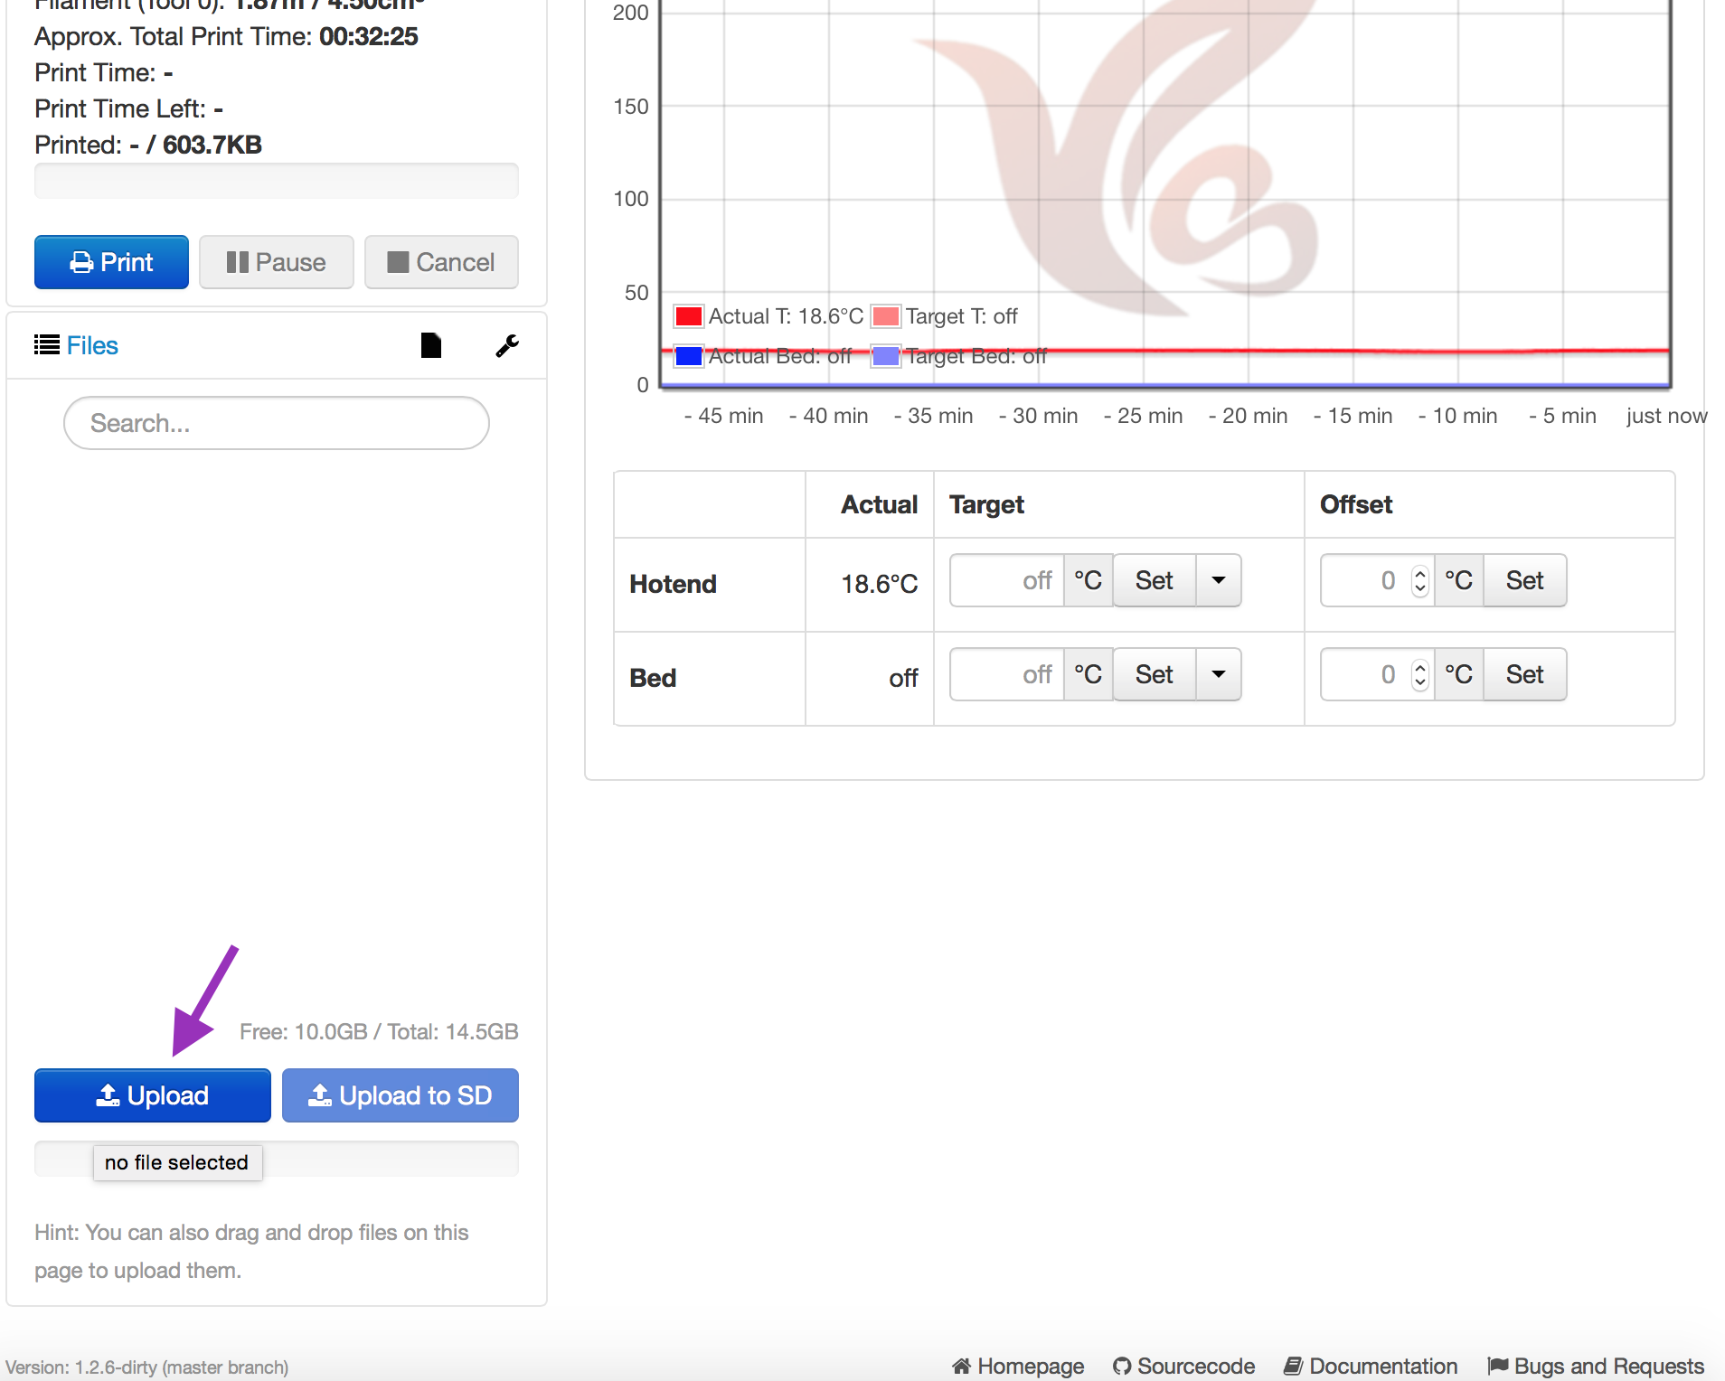

At this point, a slicer options window will pop up. On this page, you can select a profile other than the default, and you can choose whether you want to review the sliced code before printing - “Select for printing”, "Start printing" immediately, or slice only - “Do nothing”. Default, unfortunately, is “Do nothing”. (It does not do exactly nothing. The .STL model will still be sliced, and the Gcode file produced.) So if you want to print with the fewest clicks possible, choose from the menu. This page also allows you to change the default file name. For example, if the STL file is Keychain.stl, the default output file name is Keychain. (.gco is automatically affixed.) You can change it to "Keychain (CuraEngine 0 Z-offset)” so you’ll remember that this file is different from one you sliced using KISSlicer.

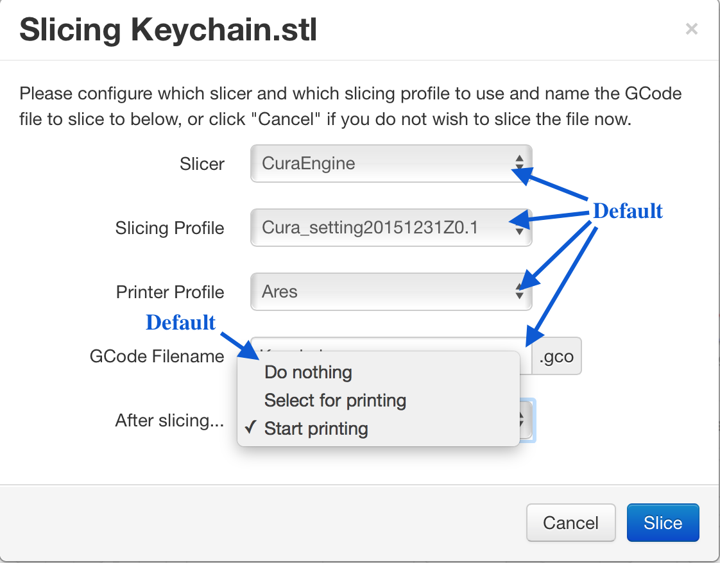

Then, click “Slice”. If you have selected “Start printing”, that is all you need to do. The browser will return to the main page, a sliding progress bar will appear to tell you where you are in upload and slicing process. Eventually, output file will appear in the printer staging area of the page, and print will start. If your choice is “Select for printing”, you’ll see the output file loaded into the staging area. You can use Gcode viewer to preview the file, or press Print to start the job.

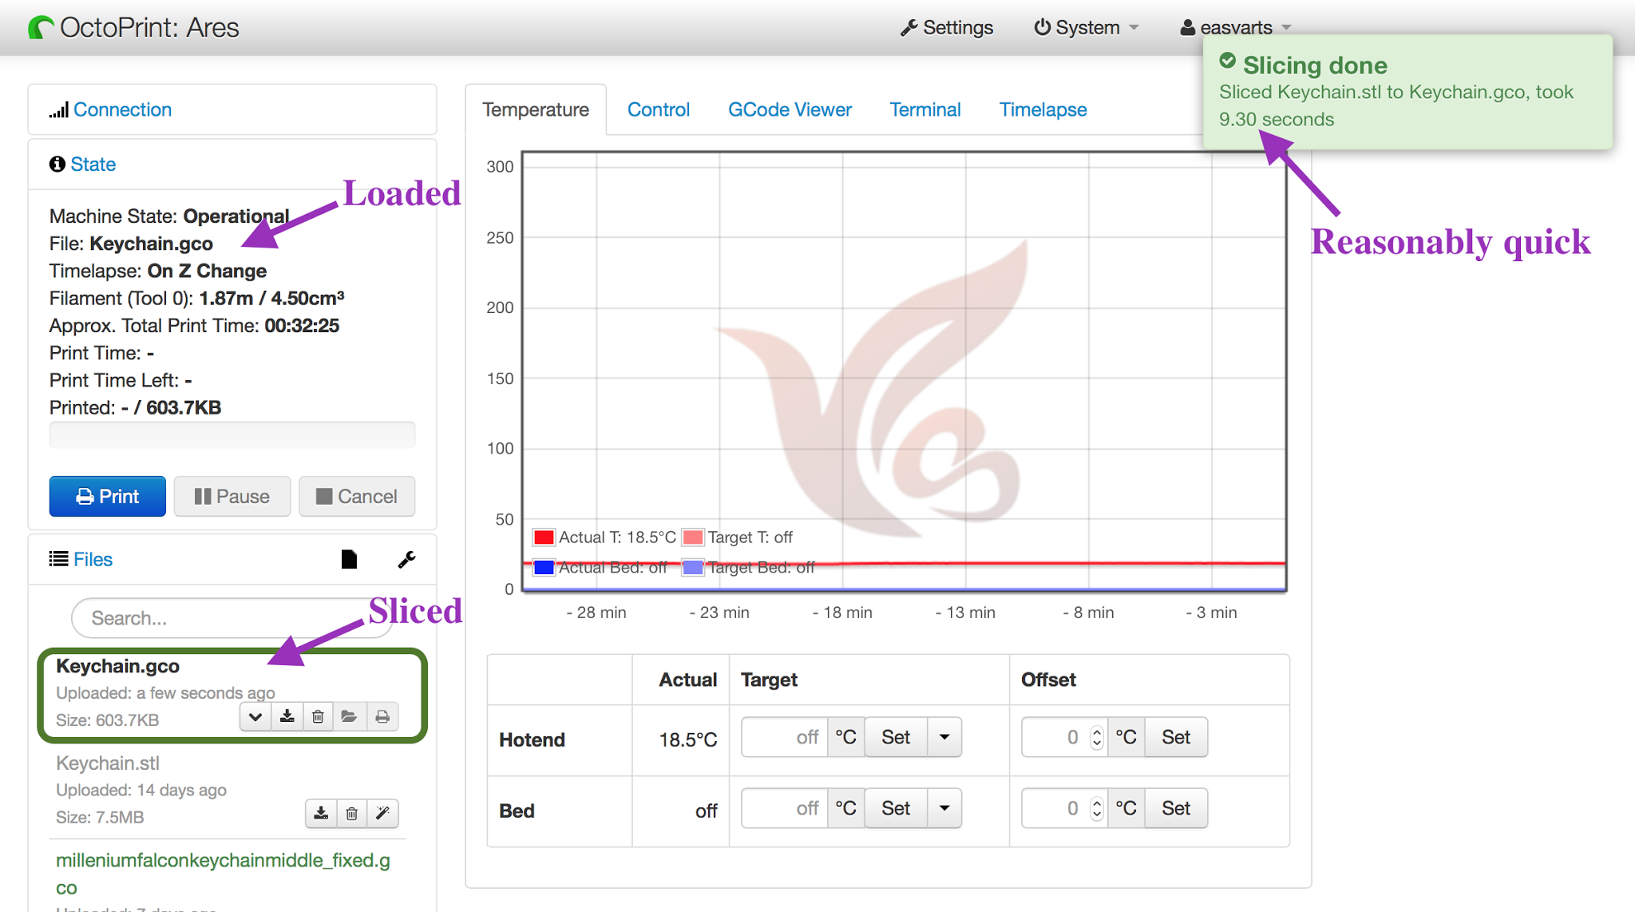

The uploaded .STL file will remain in the Files section of the main page. You can press the magic wand icon next the file description to slice it. It will give you the same popup menu shown above, so you can select print, preview before print, or just slice.

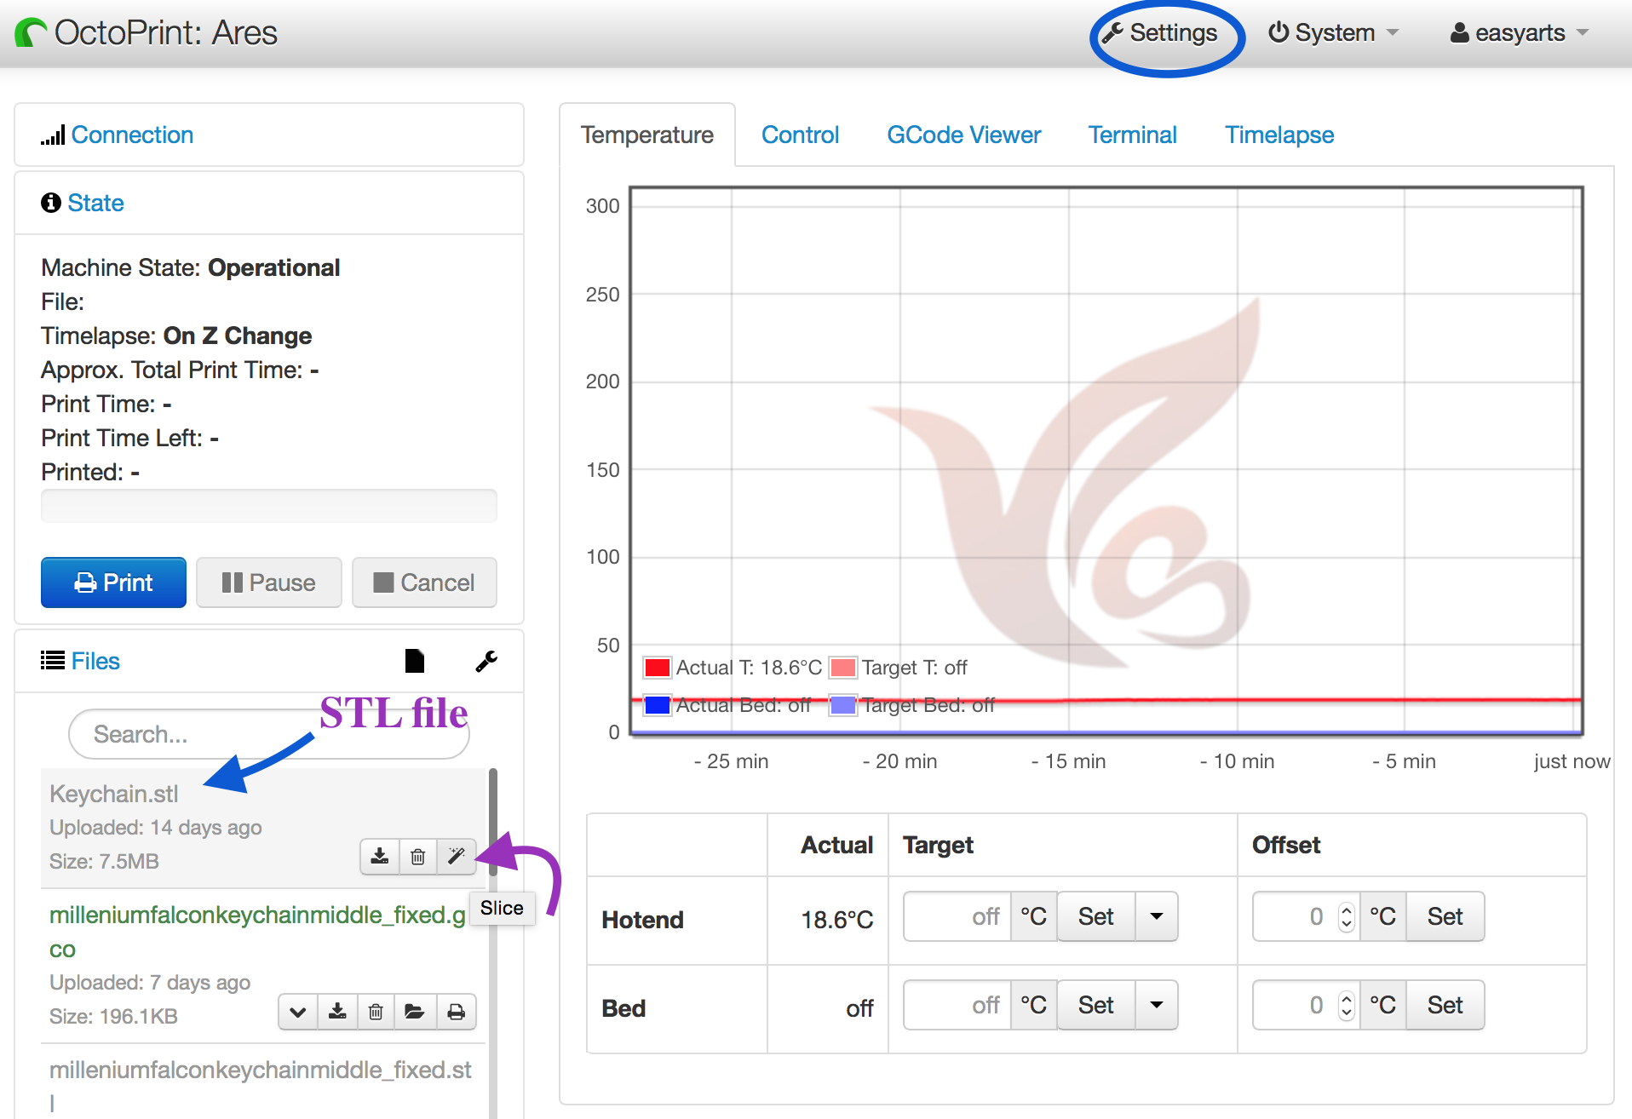

If you upload a .STL file before configuring the plugin, you cannot print the file or slice it. The magic wand is dimmed out. So how to configure your plugin?

First, click Settings on the top menu. A popup window will show OctoPrint Settings. Click Plugin Manager and you should see CuraEngine among Installed Plugins.

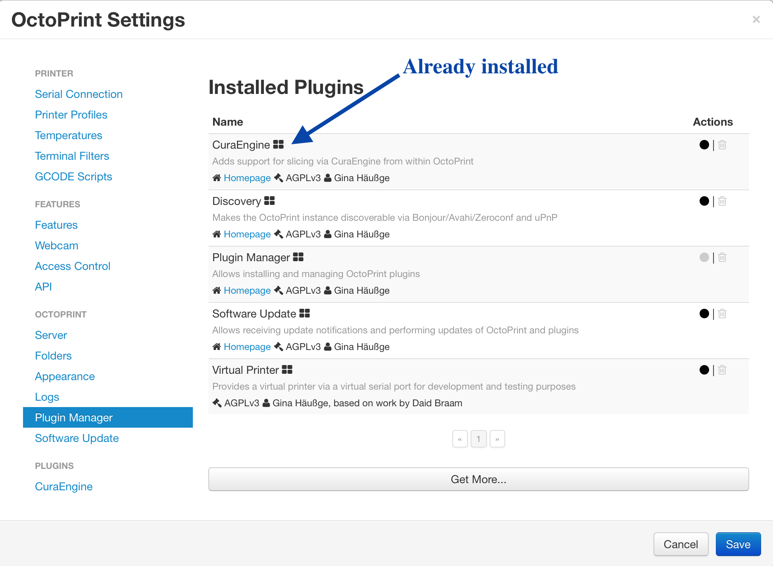

Next, go to CuraEngine under Plugins. If Path to CuraEngine is blank, just enter /home/pi/Cura/CuraEngine/build/CuraEngine into that space.[1] (See below. This is where my unit shipped in December 2015, puts the plugin; this is also where the plugin will be if you compiled the plugin in OctoPi yourself.)

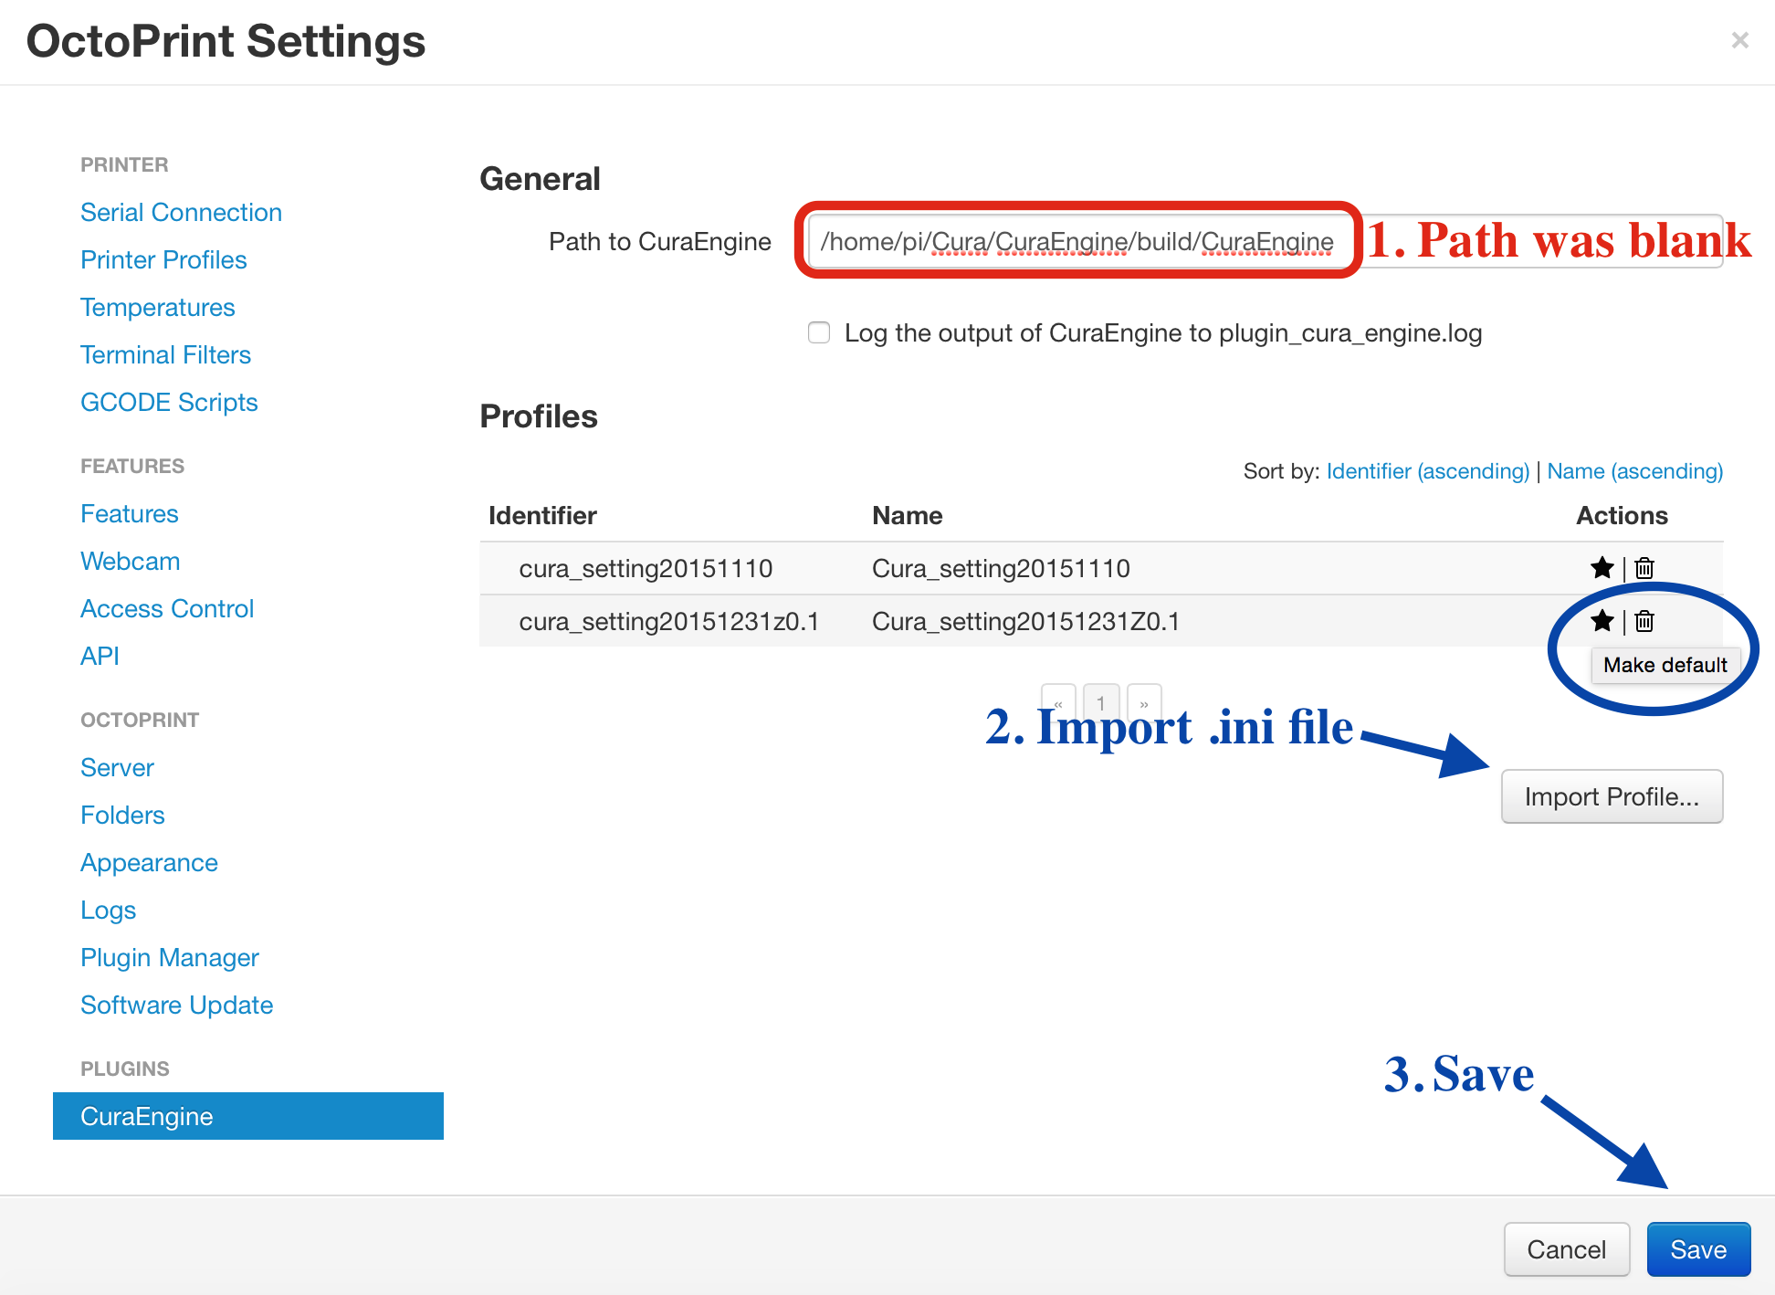

There is one more required step and one optional step.

First, you need to use Import Profile to load up a Cura profile. A Cura profile is a .ini file that can be exported from Cura up to and including version 15.04. (Cura profile has changed format since.) If you do not use Cura standalone, Easy Arts has posted one for Ares in [Slicing software--Cura setting20151110](http://www.easyarts3d.com/forum/viewtopic.php?f=19&t=14).[2] Download the file, and click “Import Profile”. Another popup window will appear, like below.

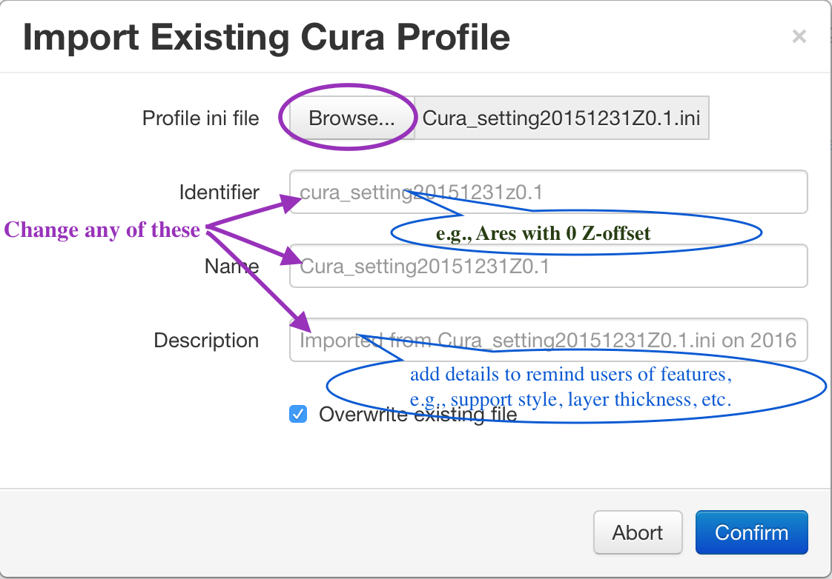

After selecting your file, you can customise how it will appear in OctoPrint. It is often easier to make a short, descriptive Identifier than using the default, which picks up the file name. Also add some descriptions to remind users why this one is different from another. Identifier is displayed in subsequent windows, so make sure the most descriptive part is in the first 15 characters or so. Name can be a bit longer, but it is only visible in the CuraEngine plugin page. Description can be viewed in the plugin page when you mouse-over the profile.

Once you press Confirm, you’ll be returned to the previous window. The uploaded profile will appear there. You can upload additional profiles. I find this useful to compensate for the lack of a full customisation menu as those in a standalone slicer. You can, for example, use one for everyday basic prints, one for high-speed testing, one for objects that needs a brim, one for super-fine prints, and so on. If you do use multiple profiles, an optional step is to select one as default, by clicking the star on the right-hand side of the Name. After that, a star will appear on the left-hand side of the Identifier, while the star on the right-hand side will dim.

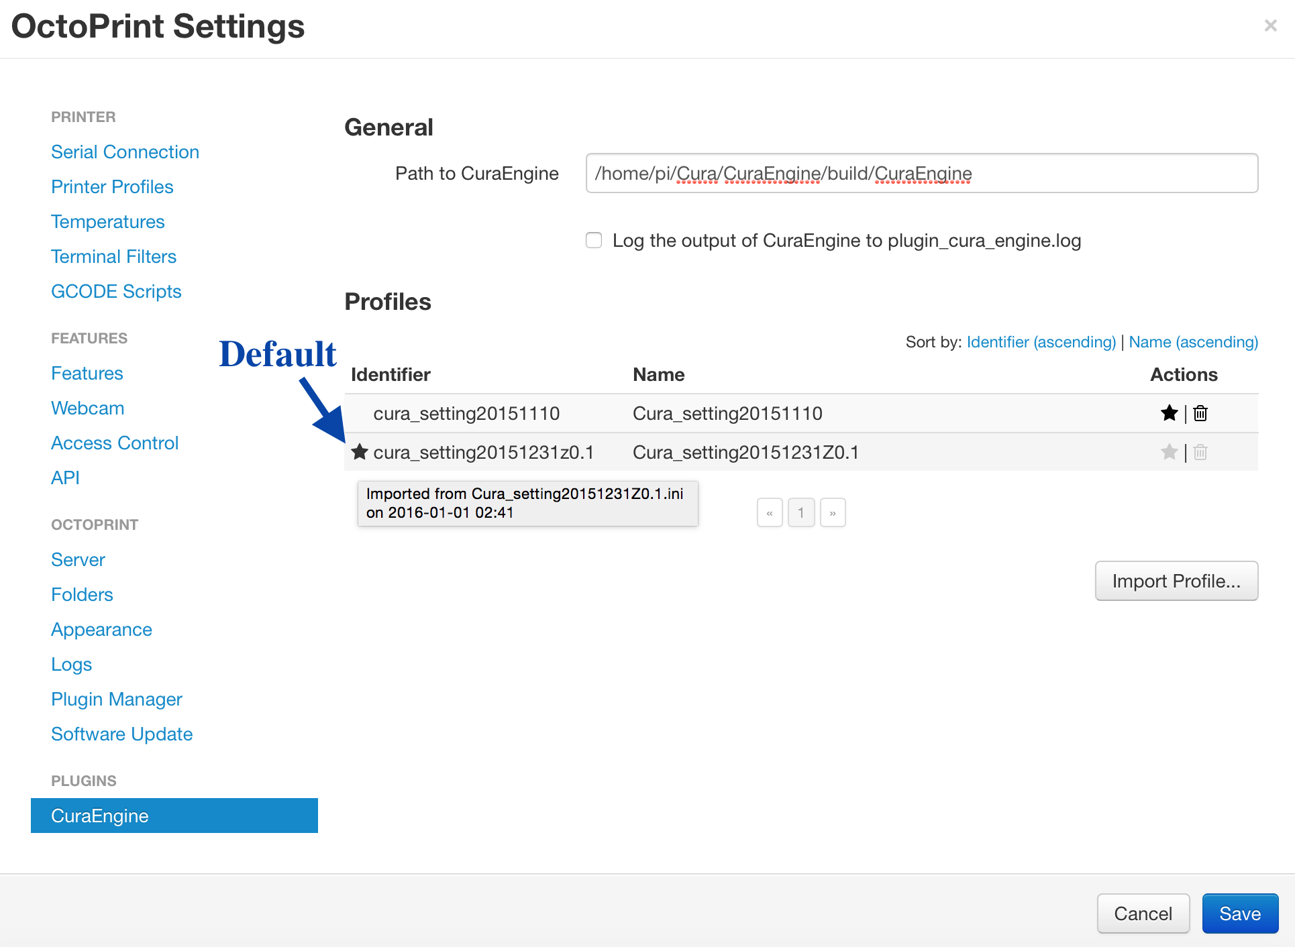

After this, click Save to return to OctoPrint’s main page. You are now ready to drag-and-drop and start printing!

Additional notes about Cura profile.

If you are not inclined to read the Cura Manual (I haven’t), this is a good overview of settings: <http://wiki.skillhouse.org/index.php/Cura_Settings_Explained>. If you have a “known-good” profile for a well-defined use case, please post so others could borrow. The Easy Arts profile is reported to be quite satisfactory. I am hoping that by creative use of “Identifier” (combined with Description), we can make “one-click printing” a (half) reality.

(This tip was first posted in January, 2016 on Easy Arts’ now defunct forum.)

1. The correct path is already set in properly released OctoPrint/OctoPi so you don’t have to make a change.
2. Unfortunately the Easy Arts forum has been down for a long time.